First of all the project is developed using SASS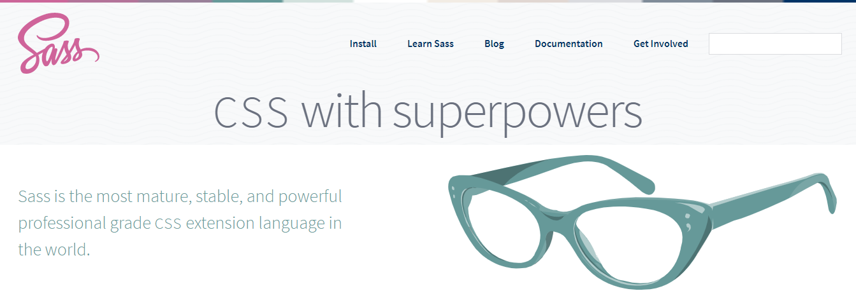

So to change any style of this project you will need **Visual Studio Code**

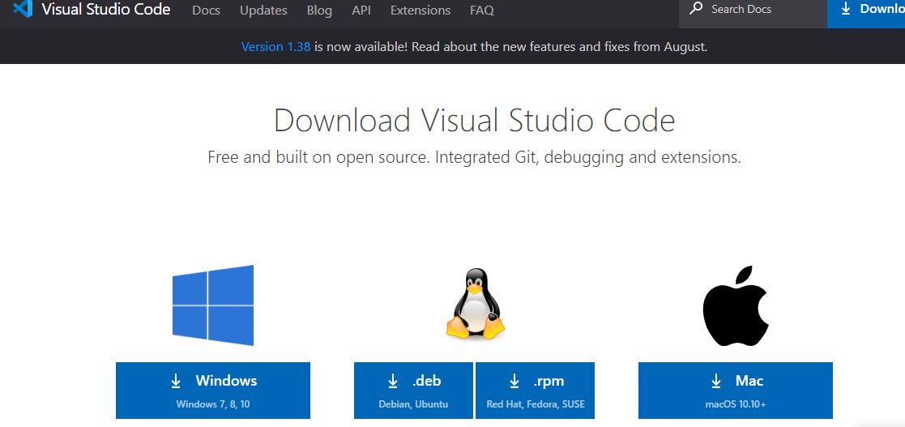

Once you install vs code you will need to install an extension call **live sass compiler**. Every time you change something on the scss file you need to click first **Watch Sass** button. 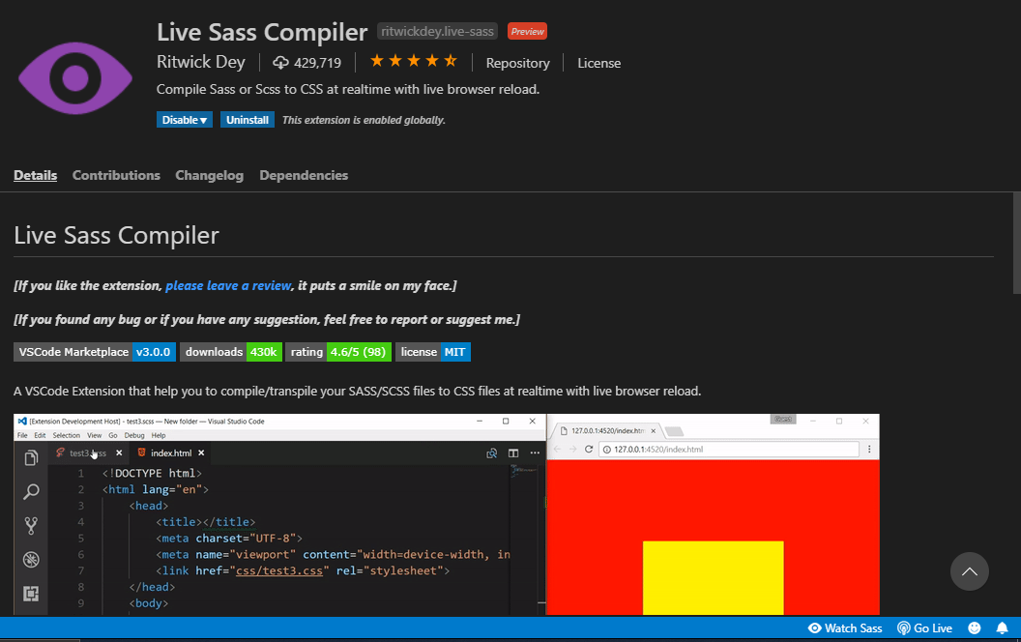

There are two types of images one is landing page type images like this one below which takes the hole width of the screen. In order to change this type of iamges you need to go to the **_banner.scss** file and change the link there.

Beside this type of image all the images links are on the html files all the section are commented you just need to change the links on the each of the section.